|  |  |
| --- | --- |
|  | Process Explorer |
|  |  |
|  | Karan (E0119039)  CSE 250 Day 1 Assignment 2  8/31/20 |

Step 1 Up and running

* Download the process explorer from <https://download.sysinternals.com/files/ProcessExplorer.zip>
* Unzip the folder using your preferred zip extractor in my case WinRAR

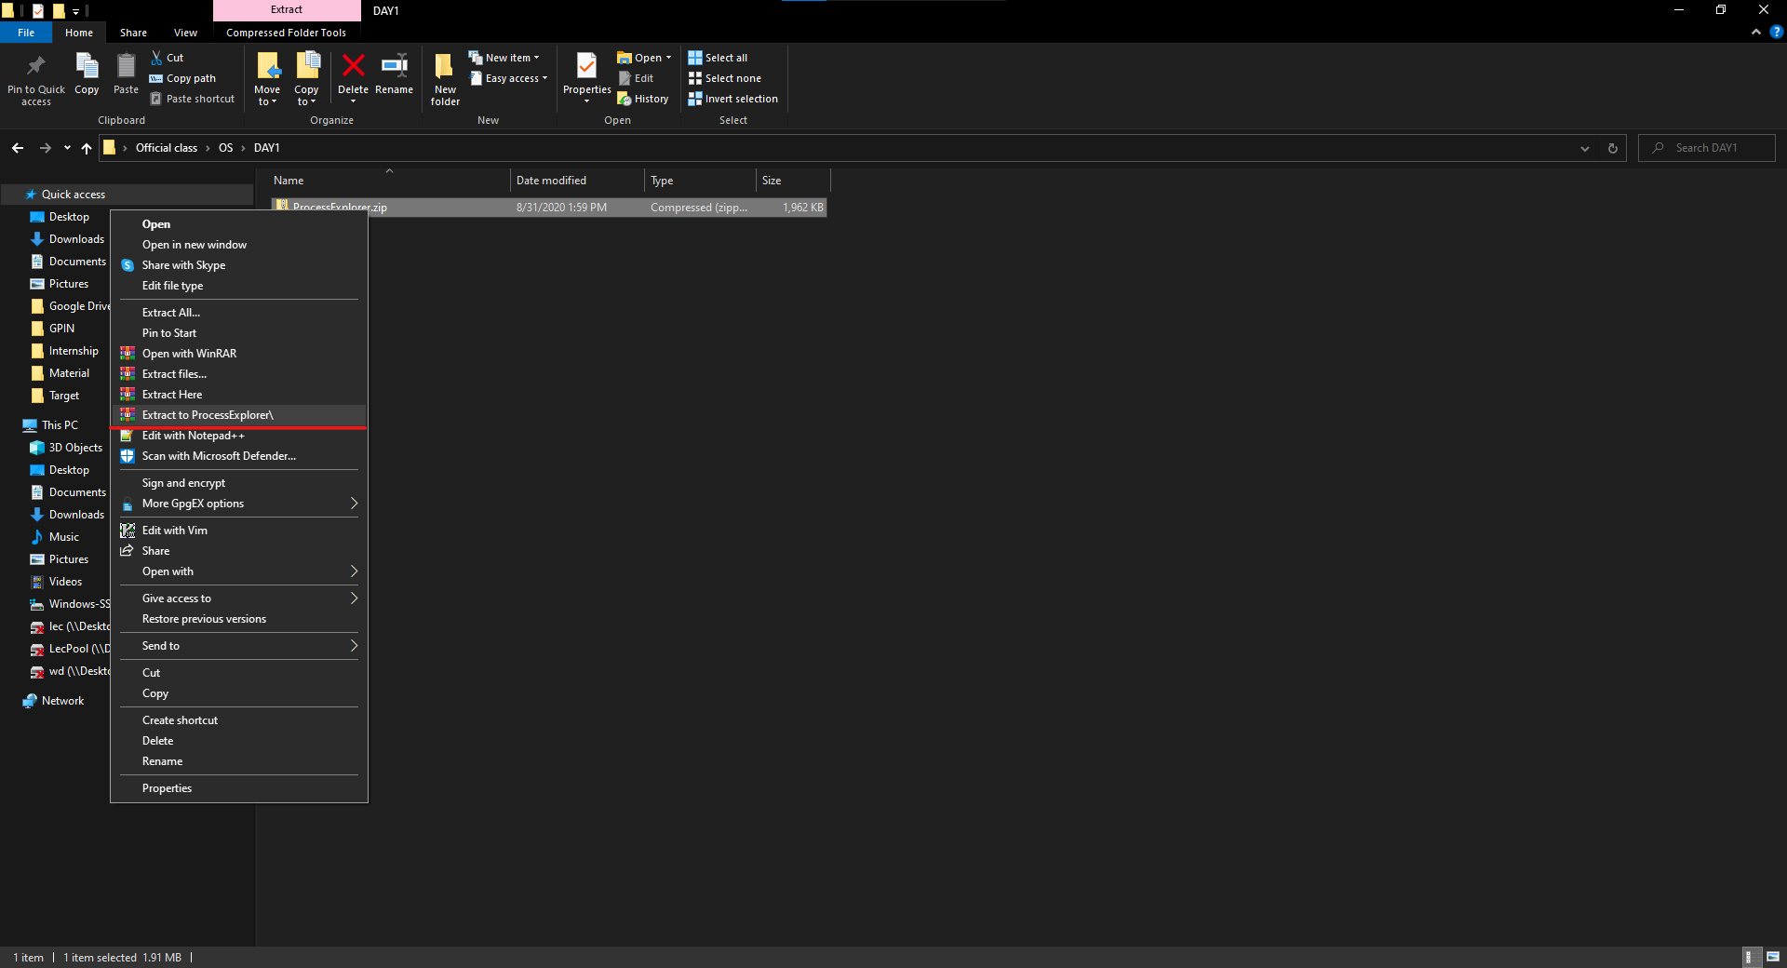

* Run the processexp.exe for 32-bit platform or processexp64.exe for 64-bit platform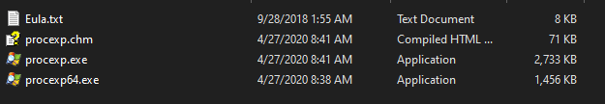

Step – 2 The App

* The opening 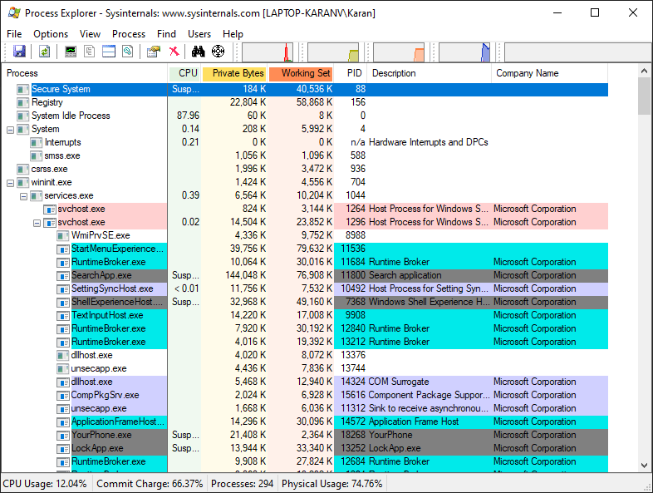
* Double click on a process in my case EDGE browser you will be presented with the below window
* 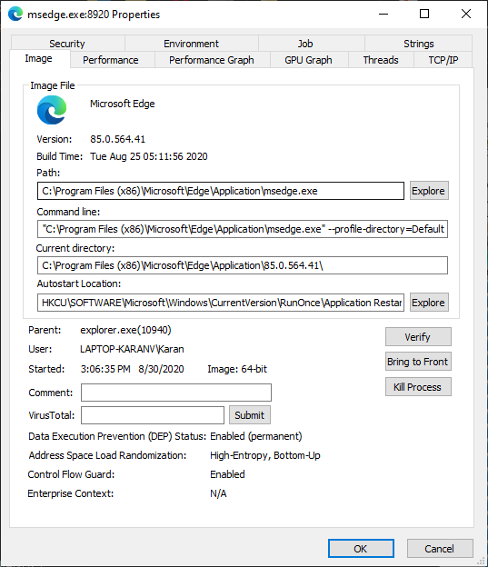
* Go to the thread tab to see the threads utilized by the app
* 
 